Time Series Analysis
Both time series d13C and d18O capture a variety of different processes like decadal vertical tectonic signals as well as annual climatic cycles. Additionally, both isotope ratios show different sensitivity for same processes.

- Moving Average [window size = 3 & 36 points] ~ raw data causes time shift!
- Resampled Time Series [1 Month]
- Removing the 36 point moving average from the signal: “tectonic free signal”

Time Domain

Event Effects
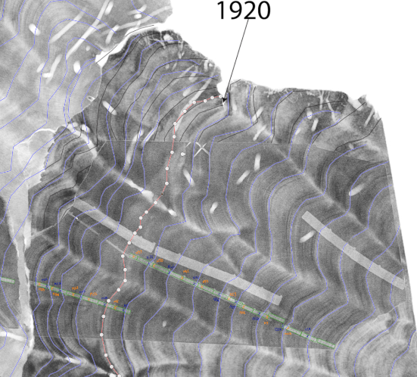
M8.1 2007 Earthquake has a significant effect on both isotope ratios derived by transect H and the morphology. d13C levels rise after the event and decreases characteristically after coming months. d18O levels do not show a strong increase, however the yearly periodicity disappears abruptly after the event. The seismic record on New Georgian Islands and its adjacent area has 4 historical >M7.0 events: 1959 MS7.2, 1952 MS7.1, 1936 MS 7.4 and 1926 MS7.2. Unfortunately, the oldest sample we collected is dated as 1927 and therefore the data doesn’t cover the oldest 1926 event. However, both x-ray radiography and d18O time series show irregularities during these events. On X-ray radiography the bands are 1.5 times wider than their surrounding years and the regular annual signal of d18O is disturbed for that specific season after both 1952 and 1959 events, likewise in 2007 event. The 1936 event has even stronger effects on the d18o time series; there is a significant drop after the event however both the periodicity and the long term trend stays unchanged. The post-seismic relaxation of 1936 event is captured by two drilling paths (end of N & start of M). Both independent samples and measurements align with each other as well as with the coral morphology.
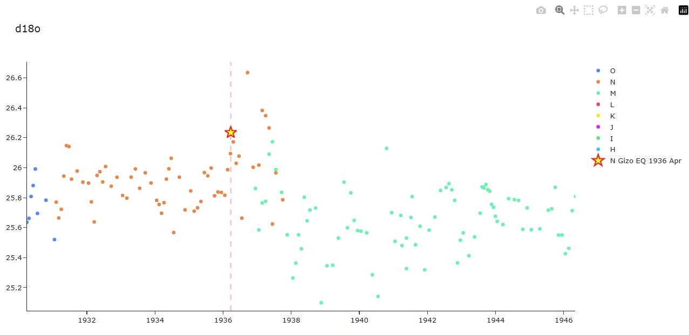
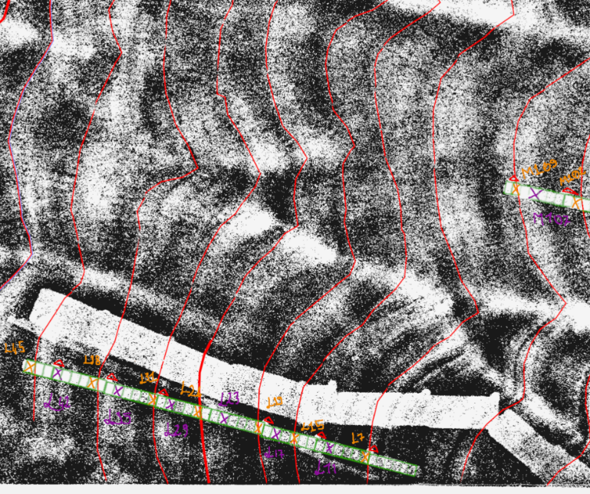
Figure 1 Green arrows are 1959 (left) and 1952 (right) bands.
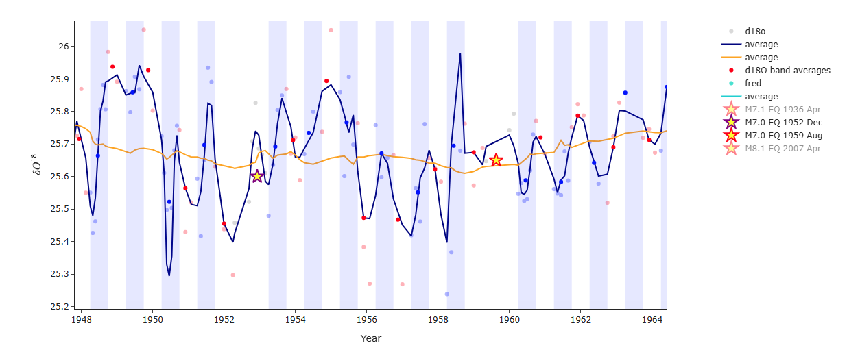
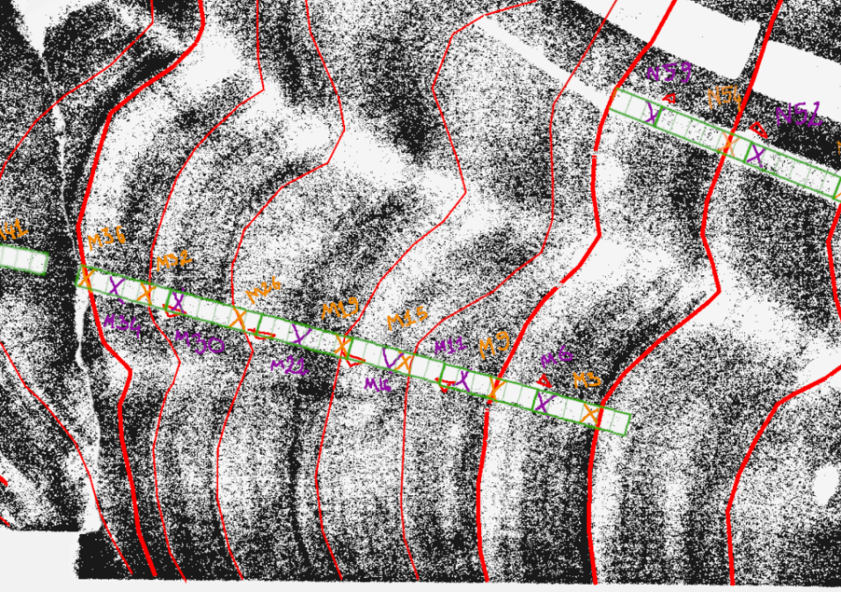
However the main puzzle raised by the 1936 event is the lack of any abrupt change in d13C for the event, while both d18O and the coral morphology of two independt corals show a die down. d13C still shows a significant decadal decay about 0.7 permille after the event, so one explanation could be that the coseismic vertical effect was minor while the postseismic change was very dominant over the next several years.
JUD: [like we also thought with Luc] The coral was on a certain [ideal] depth where both isotopes were showing stable annual cycles and the 1936 event uplifted the coral into a much shallow setting where things just started to be more sensitive for d13c but gradually and for d18o didn’t show any major change afterwards due to very homogenous salinity and temperature conditions in lagoon shallow environment.

Climatic Effects
Both d13c and d18o data sets involve an annual signal which is interpreted as the yearly climate cycle. While the annual periodicity is observable throughout the whole d18O time series, it temporally isolated in d13c. For instance, based on the wavelet analysis on the “tectonic free signal”, there is a strong annual periodicity from the oldest data point until 1936, however it abruptly vanishes with the 6 year long drop trend and it also coincides with the 1936 M7.1 event.
There are 4 major ENSO events in the last century captured by the tide gauge in Honiara; 1982/02-1984/01, 1986/09-1988/01, 1992/01-1993/01 and 1997/02-1998/10. Besides the 1997 event d13c results show a responding drop during these events.

We use external data sets
- seismic catalog
- global enso index
- tide gauge in Honiara
- WHY NOT TEMP DATA? Air temp does not work so SST but how? Sr/Ca?
The absolute value of the d13c does not correspond to relative sea level directly. The derivative of both variables have a linear relationship. H and H’ have same average values

Wavelet Analysis
The temporal errors of the coral samples are prone to lower correlation results with external 1-2 year period dominated signals. Especially the age model can cause phase shifts, therefore wavelet analysis well suited to detect if the gathered time series from the coral samples include the ENSO or tide gauge signals.
Wavelet analysis results show significant overlap between d13c time series and both ENSO and tide gauge spectrograms. There is 7 years (1995 – 2002) continuous overlapping of all signals on annual cycle which we could not determine a strong correlation in time domain. Another interesting result is that the 1936 event has an immediate effect on d13c signal. The annual signal is clearly observed in the spectrogram as it was in the time domain, however all the frequencies disappears abruptly after the event.

Main arguments supporting the robustness of the time series:
- δ¹⁸O – Annual climate correlation
- δ¹⁸O & δ¹³C – Enso correlation
- δ¹³C – morphology correlation especially the trends!
- 2007 event

Time Domain

Morphology
Most valuable observation about d13c signal in time domain is its strong alignment with the coral’s morphology. Both die down and steady subsidence or uplift events observed on the morphology are also appearing in the d13c levels and sometimes in d18o. The main motivation of this research is based on the observations gathered after the M8.1 2007 Earthquake. Results from the first drilling campaign (Kendall et al 2026) show clearly that M8.1 2007 Earthquake has a significant effect on both isotope ratios derived by transect H’. d13C levels rise after the event and decreases characteristically after coming months. d18O levels do not show a strong increase, however the yearly periodicity disappears abruptly after the event.
There is a clear die down surface in 1945 in both corals 12-SPL-A and 12-SP-A and unexpectedly d18o has a sudden drop after the event. Another remarkable observation is both the periodicity, and the long-term trend stays unchanged after the event. There is also 5 years of declining trend in d13c levels after the 1945 event and this trend is captured by two different drilling paths (end of N & start of M). Both independent samples and measurements align with each other as well as with both morphologies gathered from the corals. The decline lasts until 1950 and during this decline the annual periodicity is significantly disturbed until it recovers temporarily after June1952. Between 1950 and 1959 we observe a decadal long unchanged trend while the morphology in constantly growing which means both a relative sea level rise or a steady time in a deeper relative sea level. The strong increase of d13c starts in 1959 which is 4 years before the direction switch in down going morphology trend. Both the morphology and d13c reach the peak at the beginning of the year 1970 and they both start to decline afterwards. The sudden change in 1976 in morphology is we believe due to some recent erosion afterwards (But I need to check that again when we are at UTIG), because the growth bands are perpendicular at the upper part of the slab. Beside this there is only one single time frame where the morphology and the d13c signal showing opposite directions and it is between 1985-1993. These years also cover 2 major ENSO events but what most stands out is that d13c has strong reverse correlation with both Honiara tide gauge as well as SST during these years. After that there is 18 months of steady time followed by a strong subsidence until the M8.1 event.
Taylor et al. (2008) observed in the field that the corals were uplifted up to 2.5 m after the earthquake event in the region. 12-SPL-A is uplifted 73 cm and 12-SP-A is uplifted 44 cm. While 12-SPL-A was able to survive the uplift event, 12-SP-A died completely. 12-SPL-A morphology shows a 6 cm of vertical growth recovery which indicates at least 6 cm of post seismic subsidence in the following years. The uplift and subsidence rates during the event and its aftermath are validated also with InSAR observations from the region by Kendall et al. (2026).

Spectral Analysis
As a general nature of the paleoclimatic data, the sampling intervals usually cannot be kept machine precisely constant. We used two main approaches to run our spectral analysis on our coral data, first resampling the data in 2-month intervals and second we used lomb-scargle analysis \cite{ press1989fast} for our raw unevenly sampled time-series.
All the spectral analysis indicates clearly there are three groups of dominant frequencies in both isotope signals:
- Annual
- ENSO
- Low Frequency components

Annual Climatic Signal
Annual signal is the yearly variation dominated by the solar cycle as a direct influence on SST and partly solar irradiance effected by cloudiness and rainfall. Since our research area is in the equatorial belt the seasonal SST variations are in the range of +-3°C which is not responsible solely for the annual signal in the d18o and d13c. The rainy seasons affect the cloudiness and thereby both isotopes show a clear peak for the annual period.
The monthly averages of d18o and d13c show a 1–2-month shift in their throughs and the show a general difference in their pattern for the annual behavior which also indicates that they are influenced by different processes. D18o is much more robust and shows a clear peak between May and December while in January until April the signal is quit stable and low. D13c on the other hand shows a much more dynamic and noisier signal with one major peak at September and another minor one in March. This characteristic behavior of d13c aligns well with the monthly average of SST curve. Fig XXX shows that d18o has a negative correlation with SST while d13c has a slightly positive relationship. 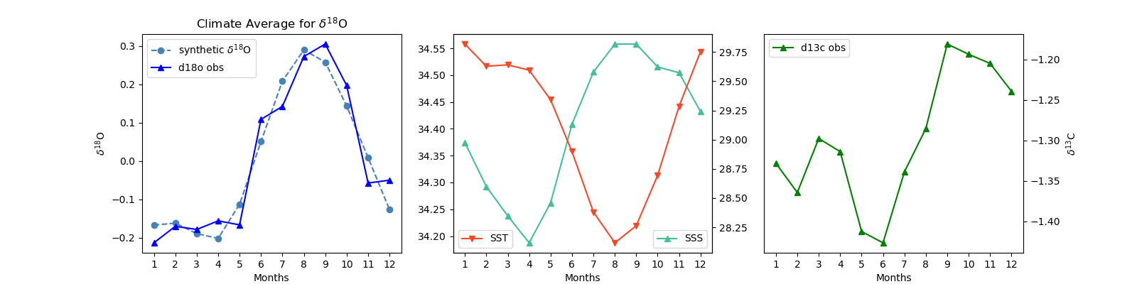

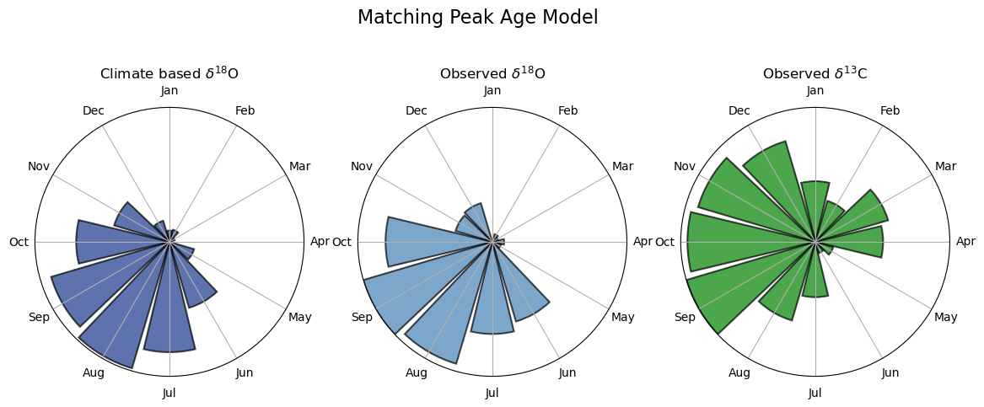

@article{press1989fast, title={Fast algorithm for spectral analysis of unevenly sampled data}, author={Press, William H and Rybicki, George B}, journal={Astrophysical Journal, Part 1 (ISSN 0004-637X), vol. 338, March 1, 1989, p. 277-280.}, volume={338}, pages={277--280}, year={1989} }

ENSO
There are 4 major ENSO events in the last century also captured by the tide gauge in Honiara; 1982/02-1984/01, 1986/09-1988/01, 1992/01-1993/01 and 1997/02-1998/10. All these events are captured with a significant rise in the d18o levels. On the other hand, d13c shows a more complicated pattern. La Nina events (positive ENSO) lead to increased SST, slightly increased rainfall, as well as lower sea levels in Western Pacific \cite{ murphy2014varied }. El Nino events result in much insignificant results compared to La Nina event however one should consider that the El Nino events also differ in two subcatogories: “Warm Pool” event with slightly positive SST and slightly negative rainfall and “Cold Tongue” events with very subtle negative SST and more negative rainfall effects. Due to this complicated multiparameter working in opposite directions for d13c, ENSO events are not always observable in d13c time series. 1977, 1987, 2005 events are observed via correlation with SST, Sea Level and ENSO-index.
Nonetheless lomb-scargle spectrograms shows several significant peaks for indicating ENSO. The strongest one on 3.1 years and the minor ones on 2.6 and 4.0 years.

@article{murphy2014varied, title={The varied impacts of El Ni{\~n}o--Southern Oscillation on Pacific island climates}, author={Murphy, Bradley F and Power, Scott B and McGree, Simon}, journal={Journal of Climate}, volume={27}, number={11}, pages={4015--4036}, year={2014}}

